Chess Game!

Erik Muro

Testing Plan:

To move a piece: you first click on the desired piece, and the square will be highlighted. Then to move, hold down the shift key and click where you want to move. This is how you move any and all pieces on the board. I can setup edge cases and check that the algorithms are correct and precise.

**Menu**

* Board – Have a drop menu for New game, Restart, Pause, and Quit.
  + New game is agreeing to start another game.
  + Restart is agreeing to end in a tie.
  + Pause the game.
  + Quit is the same as forfeit.
* Edit – Undo .
  + Undo will undo the last moved made, even if a piece was eaten.

**Score Board**

* Enter Names of players and it will keep track of your score.

**Highlight**

* Highlights square selected.

Chess Board:

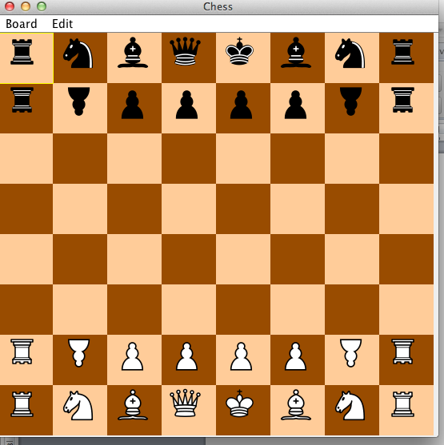

Enter Name:

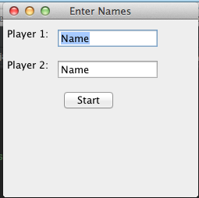

Score Board:

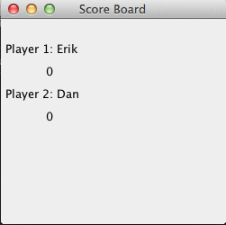

Player 2 won a game and game is paused:

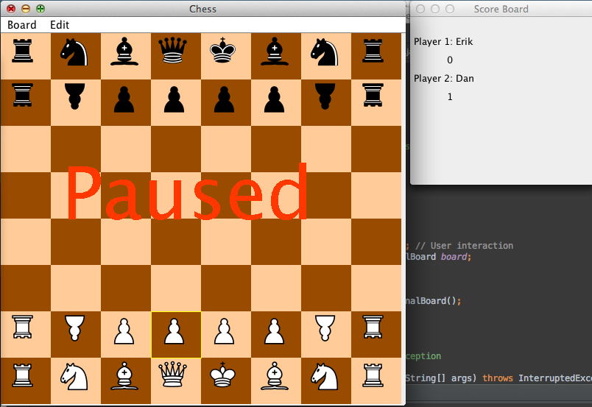

Board Menu:

